Pathway Internship Form

Thank you for your interest in The Pathway Project!

Please fill out the following form as completely as possible. This will be the information that appears on your company’s internship listing on The Pathway Project website, and viewed by the potential applicants on the site and on our Instagram page. Feel free to email thepathwayprojectid@gmail.com if you have any questions.

Company Name: _____________________________________________________________

Company Description (100-200 words):

Company Address: ____________________________________________________________

Contact Person: _____________________ Phone Number: __________________________

Contact Person’s Email: _______________________________________________________

Internship Position Title: _______________________________________________________

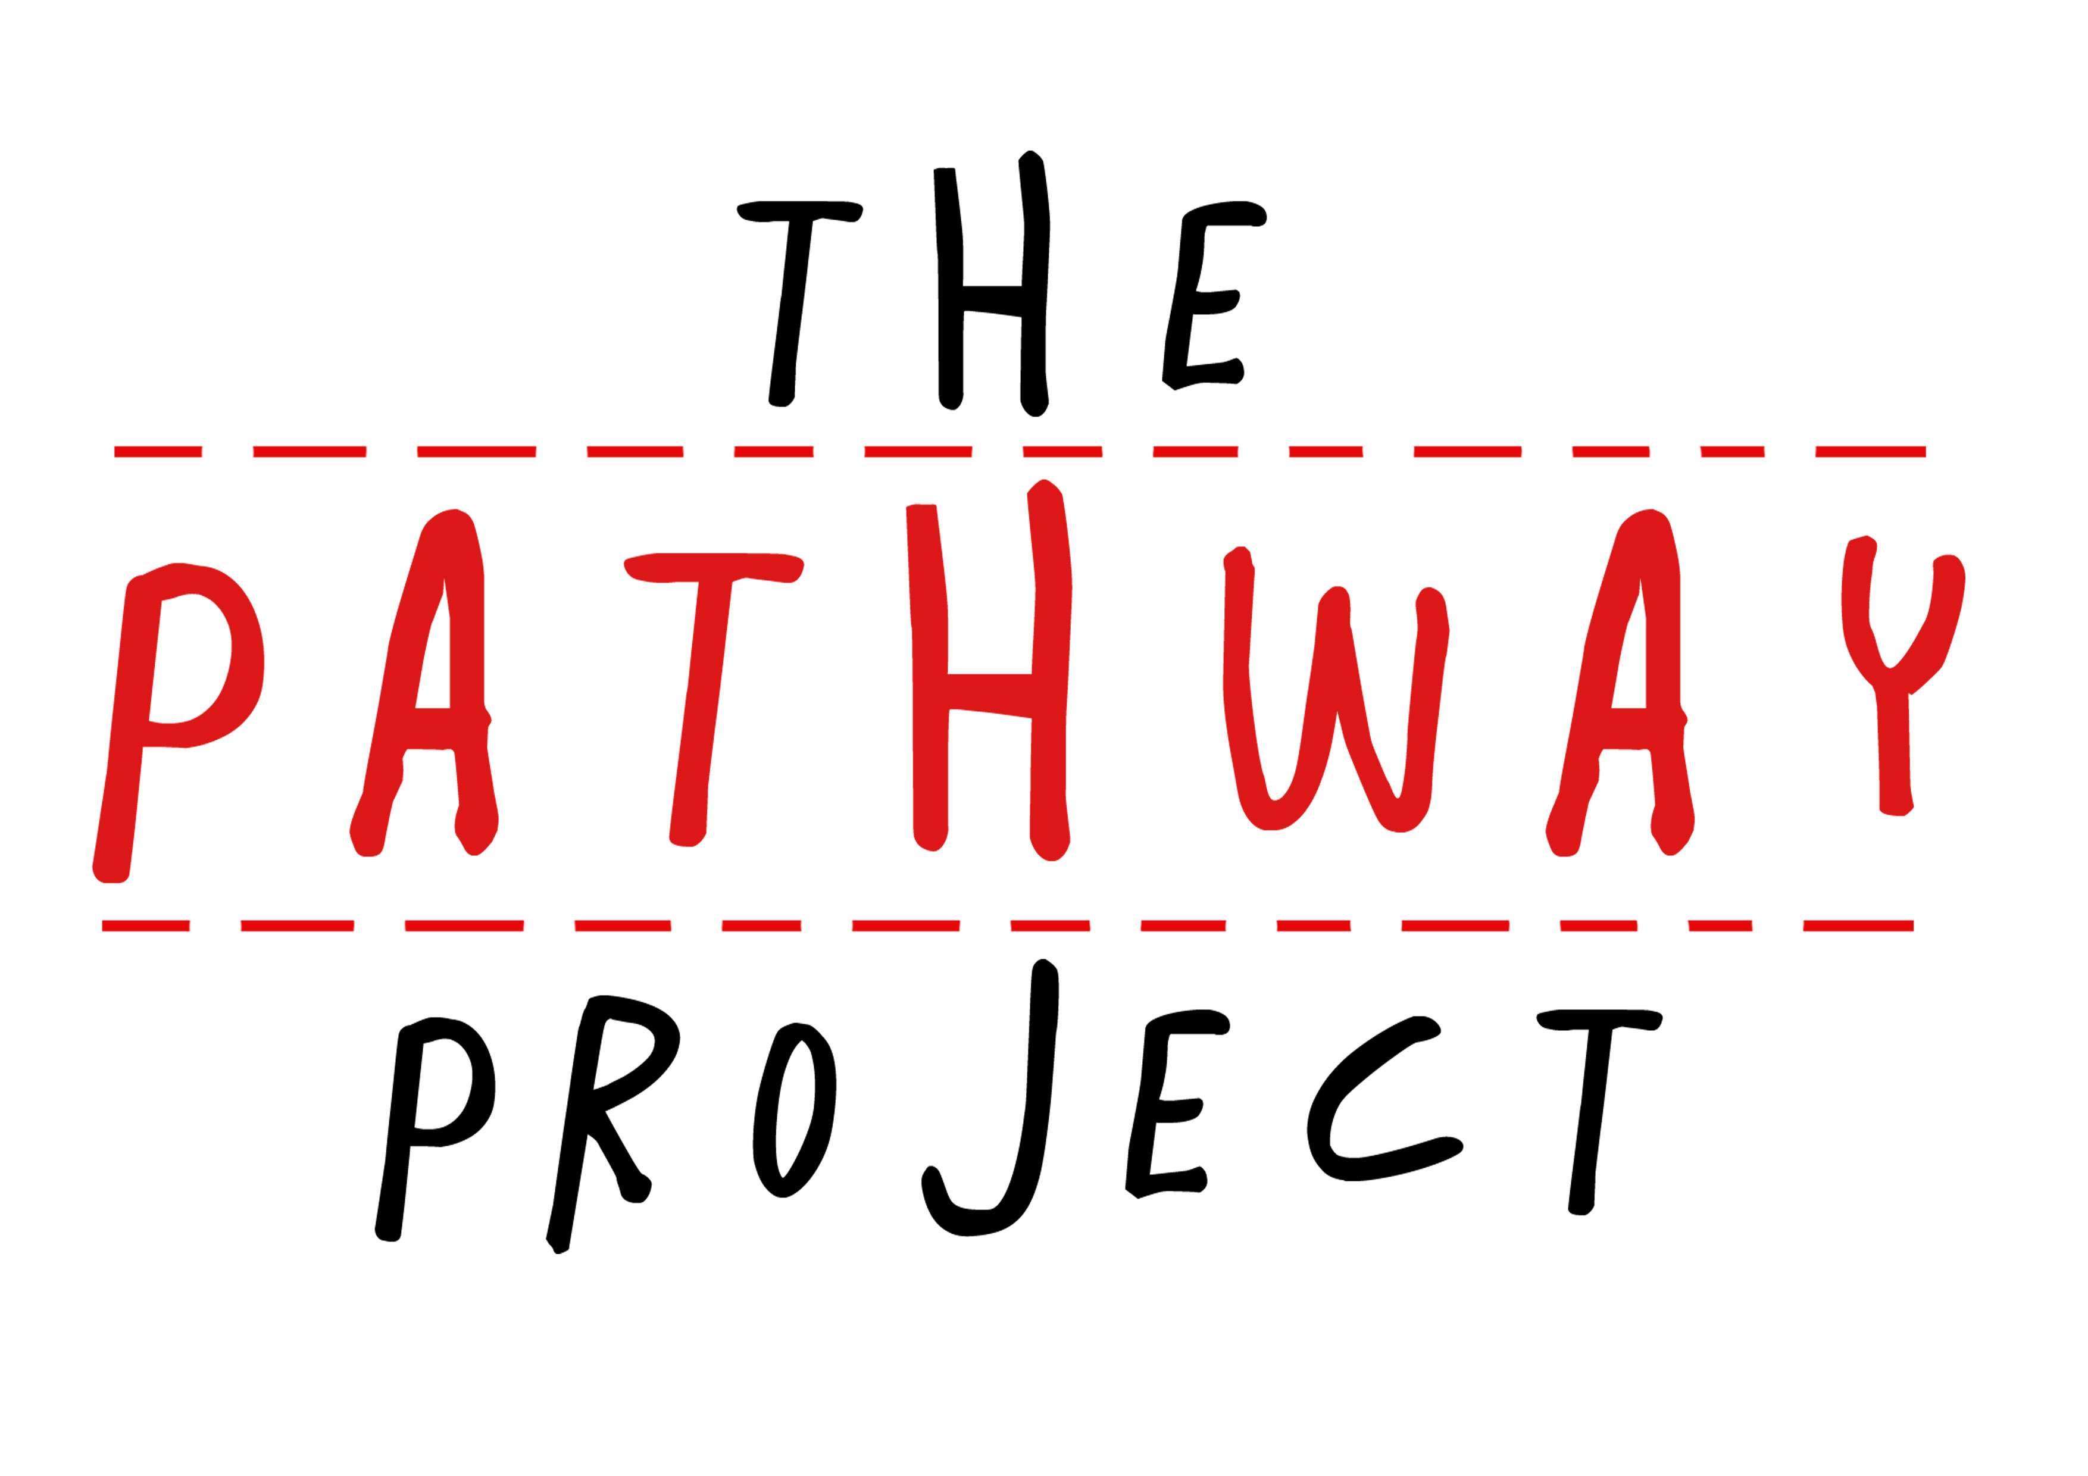
Duration of Internship: ________________________ to _____________________________

Application Deadline*: _________________________________________________________

Description of Internship:

Intern’s Responsibilities (e.g edit company newsletter, social media)**:

Requirements (e.g proficiency in English, background in science):

Maximum Number of Interns***: _____________________________________________

*You can change the application deadline later on if you choose to do so contacting a representative from The Pathway Project. The Pathway Project has already set 27 April as the standard deadline for all applicants
**Please prepare several tasks for the interns to complete. If you have any trouble with this, feel free to contact a Pathway Project representative to request a sample schedule or set up a meeting to develop a program for the internship
***If you do not have a maximum number of applicants, just type ‘0’

Company Partnership Agreement

Please read over the terms and conditions of this agreement and fill in the blanks where possible. This information will be kept confidential and only used to make sure that your company understands and agrees to The Pathway Project’s terms and conditions. Feel free to email thepathwayprojectid@gmail.com if you have any questions.

Company Name: _____________________________________________________________

Company Address: ____________________________________________________________

Duration of Internship: ________________________ to _____________________________

- Duration and Nature of Internship

- The internship will take place at your company at the above-mentioned company address.
- The internship commences and ends at the duration of internship at the above-mentioned dates.
- The duration of the internship is 2 weeks (minimum)

- Roles of the Internship Company

The Internship Company declares itself able to impart practical experience and
know-how to the student.

The Internship Company is:
- To offer instruction and training to the student during the internship duration
- To communicate with the appropriate representative of The Pathway Project with regard to any questions which may arise about the student during his/her internship
- When necessary, to inform The Pathway Project in the event of a student not showing up, beginning later, or terminating the internship prematurely

The Internship Company does not have to:
- Pay the student for the student’s services
- Provide meals for the student throughout the duration of the internship
Signed,
Company Date Pathway Project Date

________________ ________________ ________________ ________________

