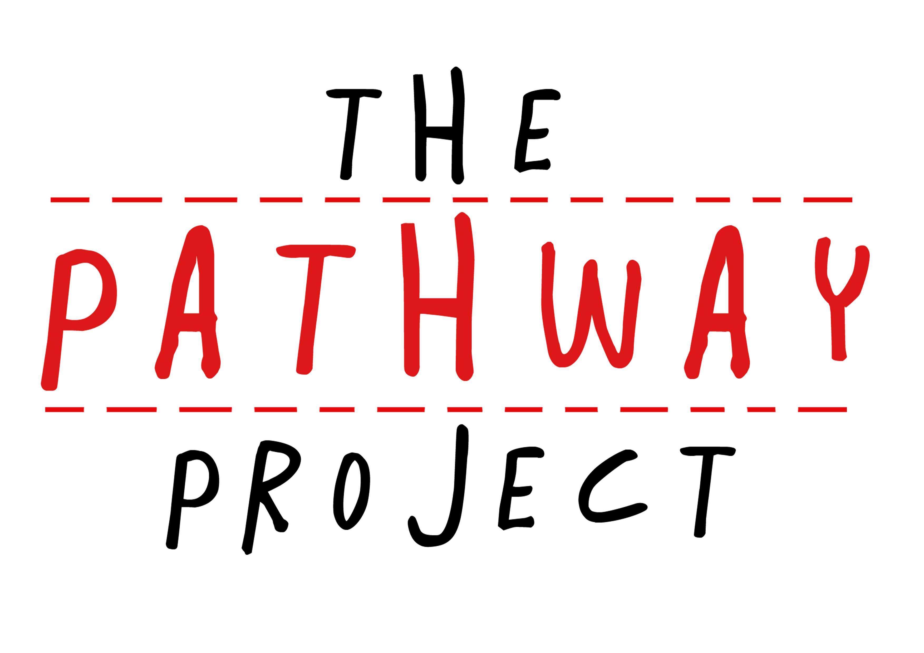
Internship Application
Thank you for your interest in The Pathway Project!
Please complete and submit the following form to be considered for our JUNE-JULY 2020 internship opportunities. Keep in mind that your responses on this form will be read by representatives of The Pathway Project as well as any potential employers.
Please only answer one of the sets of question (either English or Bahasa Indonesia)
Please send the completed application form to pathwayprojectid@gmail.com

Name:
Age:
School:
Grade Level:
Email:
Telephone Number:
Date of Application:
Internship You Are Applying For (Max. 1):

Please answer all the questions below (note: please answer only one of the two questions given for #7; and the number of words in brackets are the maximum number of words). Please enclose either a reference letter from a teacher or counselor or your CV.

Core Questions:
- Why are you interested in applying for an internship in this company? (150 words)
- What are you expecting to gain from the internship? (150 words)
- In your opinion, what is the importance of internships and how will you utilize your experience from the internship in the future? (150 words)
- What are your academic interests? (100 words)
- What skills can you offer as an intern in this company? (150 words)
- What are your weaknesses and how will you improve in those areas? (150 words)
- What was the most difficult thing you faced and how did you overcome that difficulty? (100 words)
or (only choose one question)
What is a significant challenge your society faces and how do you plan on tackling it? (200 words)
Core Question (Indonesian)
- Mengapa Anda tertarik untuk magang di perusahaan ini? (150 kata)
- Apa yang Anda harapkan dapat dari magang ini? (150 kata)
- Menurut Anda, apa pentingnya magang dan bagaimana Anda akan memanfaatkan pengalaman Anda dari magang ini di masa depan? (150 kata)
- Apa yang paling menarik untuk Anda secara akademik? (100 kata)
- Ketrampilan apa yang Anda dapat tawarkan ketika Anda magang di perusahaan ini? (150 kata)
- Apa kelemahan Anda dan bagaimana Anda akan menjadi lebih baik dalam bidang-bidang tersebut? (150 kata)
- Apa hal paling sulit yang Anda pernah menghadapi dan bagaimana Anda mengatasi kesulitan itu? (150 kata)
atau (hanya pilih satu pertanyaan)
Apa tantangan besar yang dihadapi masyarakat Anda dan bagaimana Anda berencana untuk mengatasi tantangan tersebut? (150 kata)

